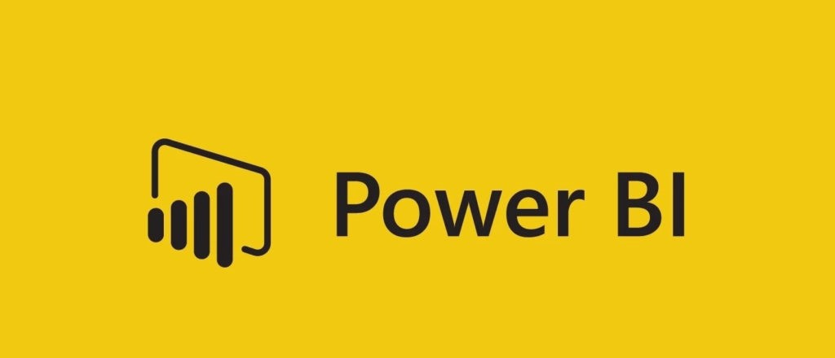
STEPS IN THE PROJECT
- Requirement Gathering/ Business Requirements
- Data Walkthrough
- Data Connection
- Data Cleaning / Quality Check
- Data Modelling
- Data Processing
- DAX Calculations
- Dashboard Lay outing
- Charts Development and Formatting Dashboard / Report Development
- Insights Generation

BUSINESS REQUIREMENT
To conduct a comprehensive analysis of Blinkit's sales performance, customer satisfaction, and inventory distribution to identify key insights and opportunities for optimization using various KPIs and visualizations in Power BI.
KPI's Requirements
- Total Sales: The overall revenue generated from all items sold.
- Average Sales: The average revenue per sale.
- Number of Items: The total count of different items sold.
- Average Rating: The average customer rating for items sold.

BUSINESS REQUIREMENT
Chart's Requirements
5. Sales by Outlet Size:
- Objective: Analyse the correlation between outlet size and total sales.
- Chart Type: Donut/ Pie Chart.
6. Sales by Outlet Location:
- Objective: Assess the geographic distribution of sales across different locations.
- Chart Type: Funnel Map.
7. All Metrics by Outlet Type:
- Objective: Provide a comprehensive view of all key metrics (Total Sales, Average Sales, Number of Items, Average Rating) broken down by different outlet types.
- Chart Type: Matrix Card.

